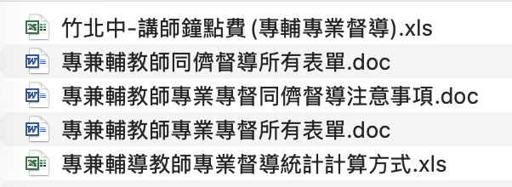
檔案下載連結
https://drive.google.com/drive/folders/1o8jCz7oT8Qh0J5PQy3yT_EfBXOHesNnq?usp=share_link

